Pollution linked to higher breast cancer risk in biggest study yet

**Kat Lay, Health Correspondent**

April 6 2017, 12:01am, The Times

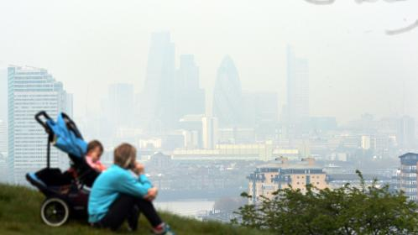

Fine particles in air pollution may include pollutants with endocrine-disrupting propertiesSTEFAN ROUSSEAU/PRESS ASSOCIATION

Share

Save

Women living in areas with high air pollution are more likely to have dense breasts, boosting their chances of developing breast cancer, a major new study has found.

Breast density has been shown to have a strong link to breast cancer. Women with the most dense breasts — the highest proportion of fibroglandular, rather than fatty, tissue — are three to five times more likely to develop the disease than those with the least.

The research, in nearly 280,000 women in the United States, found that for every unit increase in concentration of fine particles known as PM2.5, a woman’s chance of having dense breasts was increased by 4 per cent.

Fine particles in air pollution may include pollutants with endocrine-disrupting properties, potentially influencing breast density by interfering with the growth of cells in the breast, the researchers said.

They took data from mammograms and compared it with pollution data on the area where the women lived around the time of their mammogram.

The study, from the University of Florida, is the largest of its kind, and found women with dense breasts were about 20 per cent more likely to have been exposed to higher concentrations of PM2.5. Women with less dense breasts, or breasts with more fatty tissue, were 12 per cent less likely to have been exposed to high concentrations of PM2.5.

Lester Barr, chairman of Prevent Breast Cancer, said: “This is an extremely important study in the quest to prevent breast cancer.

“We know that there is no one cause of breast cancer, but breast density has a strong link to the disease and our research team in Manchester is currently researching how increased density comes about, along with ways to detect and reduce it.

“This latest landmark study is another piece of the jigsaw that will help us to protect future generations and create a breast cancer-free future.”

Although the study found that women with a density between 51 and 75 per cent had higher PM2.5 exposure than women with breast density of 25 to 50 per cent, it did not find the same for women with the highest breast density.

Graham Wheeler, medical statistician at Cancer Research UK, said: “If higher exposure to PM2.5 were associated with increased breast density, this would not be the case.”

Baroness Morgan of Drefelin, chief executive of Breast Cancer Now, said: “Breast density is an important risk factor in the development of breast cancer. We do know that there are simple steps all women can take to reduce their risk of breast cancer, such as being physically active, maintaining a healthy weight and reducing alcohol intake.”

The researchers also looked at the association between ozone exposure and breast density, finding that every unit increase in ozone concentration was associated with a 3 per cent lower chance of having dense breasts.

Lusine Yaghjyan, lead author of the study, said: “This is an intriguing result that warrants further investigation to unpick any possible biological mechanism that might cause ozone exposure to reduce a woman’s chance of having dense breasts.”